General
- Minimize Credit Risk Goal exercise quite difficult.
- Rephrase and clarify lab 6.1: b, c, d overlap quite a lot.
- Add definition of GOAL, DOMAIN, (CONNECTION??), WHY, HOW, CONFLICT, etc.
- Add some thumbnails to some slides e.g. info-partition info to collaboration slides 7.20, 7.21
- Fix page numbering using FinePrint e.g. A-1, A-2 … for appendices; F-1, F-2… for front matter
- Change layout of exercises, solutions
- Add posters
- Change LegalEntity-Client from subtype to association.
- Switch to XML / HTML
- Write script to generate an index, glossary, chapters, TOC, headers/footers/breadcrumbs, …
Old stuff
- Add stuff from Richard Mitchell’s analysis by contract (slides, solution, high-quality-modeling).pdf
- Consider adding Mitchell’s separation: modify state separate from trigger external interaction.
- Add Mitchell’s 6 principles (and Java examples from 2002 JavaOne?)
  - P1. Separate queries from commands
  - P2. Separate basic queries from derived queries
  - P3. For each derived query, write a postcondition that specifies what result will be returned, in terms of one or more basic queries
  - P4. For each command, write a postcondition that specifies the value of every basic query
    - Change or add supporting queries to make these clear
  - P5. For every query and command, decide on a suitable precondition
  - P6. Write invariants to define unchanging properties of objects 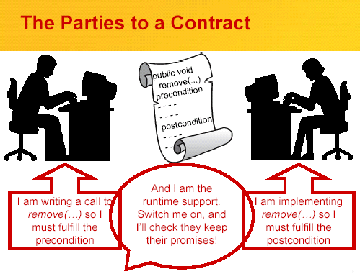
- Consider adding Wing’s hints for Specifiers
- Check time-line → 3.5 days + workshop??
- Add risk management example
- How to describe messages sent in a post condition?
- Add info model partitioning and invariant at domain → bbox → wbox
- Improve arch styles and technical architecture
Ch 1 Introduction (Objects, Actions, Components)
Ch 2 Method Overview
- tornado model
Ch 3 Basic Modeling Techniques
- Change “Concrete” → “Example” or “Test case” ; Abstract → Model or Spec
- Add “Abstract” dimension: show it in both model and test.
Ch 4 Integrated Modeling Techniques
Ch 5 Business
Ch 6 Black Box
Ch 7 White Box
- Add layer / tier slides (see CFR)
Ch 8 Technical
Ch 9 Deployment
Ch 10 Code
Ch 11 Advanced

